Note: Những bài tiếng anh chỉ để các bạn tập làm quen với dạng đề
Question1: Given the following dataset with one feature X and target Y:
 | X | Y
P1 | 1 | 2
P2 | 2 | 4
P3 | 3 | 5
P4 | 4 | 4
P5 | 5 | 5
We want to fit a linear regression model ŷ = w₀ + w₁X using gradient descent. Use MSE loss:
$$L(w)=\frac{1}{N}\sum_{i=1}^{N}{(}{\hat{y}}^{i}-y^{i})^{2}$$
- Write down the gradient of L with respect to w₀ and w₁. Show your derivation.
- Starting from w₀ = 0, w₁ = 0 and using learning rate η = 0.01, perform 2 iterations of gradient descent. Show all calculations and round to 3 decimal places.
- After your 2 iterations, what is the MSE loss? Did it decrease compared to iteration 0? What does this tell you?
- If the learning rate is set too high, what can happen during training? Sketch or describe the loss curve behavior.

Question 2: Given the following binary classification dataset:
 | X₁ | X₂ | Y
P1 | 1 | 2 | 0
P2 | 2 | 1 | 0
P3 | 3 | 3 | 1
P4 | 4 | 2 | 1
P5 | 5 | 4 | 1
We use logistic regression with sigmoid: σ(z) = 1 / (1 + e⁻ᶻ), where z = w₀ + w₁X₁ + w₂X₂, and Binary Cross-Entropy loss:
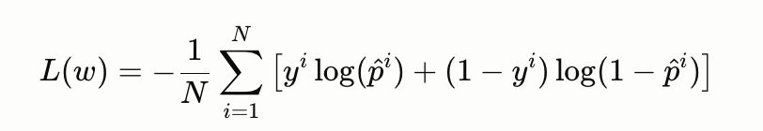
- Write the gradient of L with respect to w₀, w₁, and w₂. You may use the known result that ∂L/∂wⱼ = (1/N) Σ (p̂ⁱ − yⁱ)xⱼⁱ.
- Starting from w₀ = 0, w₁ = 0, w₂ = 0 and learning rate η = 0.1, perform 1 iteration of gradient descent. Round to 3 decimal places.
- Compare logistic regression gradient descent to linear regression gradient descent. What is structurally similar and what is different?
- What is the decision boundary of this model? After your 1 iteration, write the equation of the decision boundary and describe what it looks like geometrically.
Câu 3: Given the following 2D points as your training data:
Point | Coordinates (x, y) | Label
A | (1, 2) | 0
B | (2, 3) | 0
C | (3, 4) | 1
D | (5, 1) | 1
Suppose we want to classify the test point T = (2, 2) using k = 3. Which points are the nearest neighbors and what will be the predicted label?

Câu 4 You are given a dataset of people and whether they Buy Computer based on Age and Income:
ID | Age | Income | Buy Computer
1 | Young | High | No
2 | Young | High | No
3 | Middle | High | Yes
4 | Senior | Medium | Yes
5 | Senior | Low | Yes
6 | Senior | Low | No
7 | Middle | Low | Yes
8 | Young | Medium | No
9 | Young | Low | Yes
10 | Senior | Medium | Yes
Compute the Information Gain for each feature (Age and Income) and determine which feature gives the higher gain.

